CSE442/542 Phase Three November 17th 2013



Team 30: Scott Laufer, Satya Prakash Bhukar, Sinchan Bhattacharya,Ankur Saran, Vincent Graziano, Victoria Minorczyk,Biplap Sarkar, Samuel Morris, Shannin Ciprich

BreathEasy PAS (Portable Air Senor)

SRS

Table of Contents

|  |  |
| --- | --- |
| **Section I: Functional Requirements**  1.1 Top-Level Description  1.2 Senor Module  1.3 Android App  1.4 Complete Architecture | 2  2  4  5 |
| **Section II: Integration Thread**  2.1 Top-Level Description  2.2 Integration Thread Diagram  2.3 References | 7  8  8 |
| **Section III: Cross Reference List** | 9 |
| **Section IV: Change Request Form** | 12 |
| **Section V: Sample User Screens**  4.1 Home Screen  4.2 Diagnostics Screen  4.3 Settings  4.4 Status Bar Icons | 14  15  16  18 |
|  |  |

**Section I: Functional Requirements**

1.1 Top-Level Description

1

The system will be divided into two major components: the sensor device, and the Android app. The sensor module will be capable of long-term functionality independent of the Android app.

1.2 Sensor Module

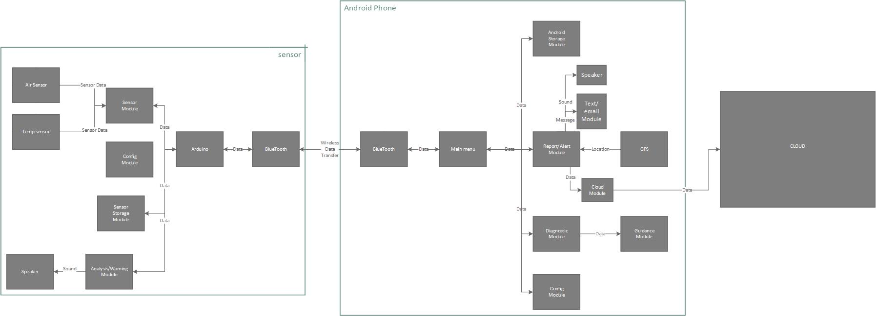

2

The sensor device will be an array of sensors attached to a device which will provide minimal interaction with the user. These sensors will monitor the quality of the air in the user’s environment.

a. Hardware

3

The abstract hierarchal organization of the components will be:

* Arduino platform
  + Non-volatile (flash) storage
  + Sensor array
    - Airborne particulate (i.e. dust and volatile organic) sensor
    - Temperature Sensor
  + Speaker
  + Bluetooth radio
  + Battery

4

The Arduino platform will serve as the base system of the sensor device. Firmware will be loaded from the onboard non-volatile storage device. This firmware will contain a basic set of operations that will allow the device to issue warnings, and to collect data to synchronize with the Android app.

b. Firmware

5

The sensor device firmware will consist of 4 modules:

* Sensor device firmware
  + Database module
  + Sensor module
  + Configuration module
  + Analysis/warning module

6

The database module will act as an interface to the internal storage device. Database schema will depend upon future testing and storage needs.

7

The firmware sensor control module will collect data from the sensors, storing it in the device’s internal storage via the database module until synchronization with the Android device occurs.

8

The configuration module will receive configuration settings from the Android device during synchronization, including thresholds for airborne contaminants that will be used by the analysis module. These will be stored via the database module, allowing the sensor device to provide air quality warnings without the presence of the Android device.

9

The analysis/warning device will perform minimal analysis of air quality data (i.e. whether or not a certain contaminant has exceeded a configured threshold) based on settings from the configuration module. When necessary, it will activate the speaker in order to alert the user.

1.3 Android App

10

The primary purpose of the Android app is to perform detailed analysis of data recorded from sensors. It will also allow the notification of caregivers based on certain criteria (e.g. persistent poor air quality readings).

11

The abstract hierarchal structure of the Android app will be:

* Main Menu
  + Storage module
  + Report module
  + Diagnostic module
    - Guidance module
  + Configuration module

12

The main menu will allow the user to access other functions, as well as provide an “at-a-glance” summary of air quality status as most recently reported by the sensor device.

13

The storage module will provide an interface to the Android device’s internal storage. It will also provide the capability to back up stored data on a remote server (See system requirements, “Cloud”) to prevent data loss in the event that the Android device is lost or damaged.

14

The report module will have the ability to send reports to caregivers via text or email in the event that it becomes necessary (e.g. persistent exposure to high levels of air contaminants). These reports may include the user’s location, as reported by the Android device’s GPS (if available).

15

The diagnostic module will analyze data collected from the sensor device, and use create useful visualizations (e.g. histograms of contaminant density) to aid the user in managing their environment. This will include visualizations of aggregate air quality, as well as concentrations of individual contaminants.

16

The guidance module will ask the user a series of questions regarding their present condition, and determine the correct course of action to treat their current symptoms (e.g. use rescue inhaler, use controller medication, call a doctor, call 911, etc.), and, if necessary, send an alert to caregiver(s) via the report module.

17

The configuration module will contain settings for all other modules, including contaminant thresholds and report module alert settings. This module may be configured to require a PIN for access.

1.4 Complete Architecture

The complete architecture for the BreathEasy PAS system is shown to the right.



**Section II: Integration Thread**

2.1 Top-Level Description:

Integration thread is a single strand of reduced capability that extends through the entire system. It is a simple, but representative subset of the system, which reduces complex problem to a small chart. The subset must be stable and flexible to serve as a foundation to which the remainder of the system can be added.

Our integration thread includes the following modules:

1. Sensor module – Air sensor
2. Sensor Storage Module
3. Analysis/Warning Module
4. Report/Alert Module – GPS, Text/Email module
5. Android Storage Module

Air sensor such as Futurlec will be responsible for sensing: smoke, NOx, Ozone, SO2 etc. These are only a few known triggers of Asthma attacks. If the sensor module detects unwanted particles in the air it will communicate with the Analysis/Warning module. This module will signal an audible alert to the patient through the small built-in speaker along with a gentle vibration alert. Severity will be decided on the basis of concentration of particles. With the help of Bluetooth the data will be transferred to an android phone. The android phone Report/Alert module will gather the GPS coordinate and store all this information in the android storage module. Depending on the severity of particle concentration, the Report/Alert module may alert caregivers through the Text/Email module.

In the case that the senor is unable to connect via Bluetooth to the phone, the data will be stored temporarily in the sensor storage module and will be automatically transferred to android storage module when a connect can be made.

2.2 Integration Thread Diagram:

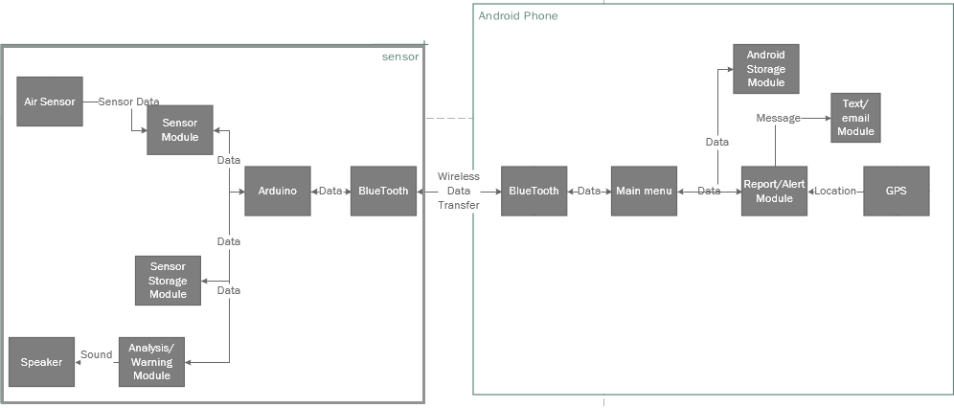Below is the subset of modules need from the functional requirements to complete the integration thread.

2.3 References:

The follow references were used to complete section II.

<http://www.futurlec.com/Gas_Sensors.shtml>

[http://www.howmuchsnow.com/arduino/airquality/grovedust](http://www.howmuchsnow.com/arduino/airquality/grovedust/)

**Section III: Cross Reference List**

|  |  |  |  |  |
| --- | --- | --- | --- | --- |
| Completed | ID | System Capability | Location in System Spec | Location in SRS (page) |
| SENSOR CAPABILITES | | | | |
|  | 1 | Sensor can collect air samples | Sensor Module  &  Air Sensor | 2 |
|  | 2 | Sensor can detect individual air borne pollutants: molds, pollens, tobacco smoke, dust particles, combustion by-products, pet dander | Sensor Module  &  Air Sensor | 2 |
|  | 3 | Sensor can detect atmospheric temperatures | Sensor Module  &  Temperature Sensor | 2 |
|  | 4 | Sensor can detect concentration of individual air borne pollutants | Sensor Module  &  Air Sensor | 2 |
|  | 5 | Sensor can store data short term (up to 1 month) onboard until it is transmitted to phone app | Sensor Storage Module | 2 |
|  | 6 | Sensor can be programmed to detect specific air pollutants | Sensor Configuration Module | 2 |
|  | 7 | Sensor can be programmed to detect specific concentrations of air borne pollutants | Sensor Configuration Module | 2 |
|  | 8 | Sensor can received configuration information from module | Bluetooth Module | 2 |
|  | 9 | Sensor can communicate with (send collected data to) phone | Bluetooth Module | 2 |
|  | 10 | Sensor can analyze data collected (pollutants, concentrations, and temperatures) and conclude if these levels have reached the programmed thresholds | Sensor Analysis/Warning Module | 2 |
|  | 11 | Sensor can alert user if thresholds are exceeded in event the phone alert fails | Sensor Analysis/Warning Module  &  Sensor Speaker | 2 |
| PHONE APP CAPABILITIES | | | | |
|  | 12 | Phone can receive collected data from sensor | Bluetooth Module | 5 |
| Completed | **ID** | **System Capability** | **Location in System Spec** | **Location in SRS (page)** |
| PHONE APP CAPABILITIES CONTINUED | | | | |
|  | 13 | Phone can store data received from sensor short term storage (up to 1 month) | Phone Storage Module | 5 |
|  | 14 | Phone can upload data to cloud for long term storage incase phone is damaged (up to 5 years) | Cloud Module | 5 |
|  | 15 | Phone can upload data to cloud for parental and user online access | Cloud Module | 5 |
|  | 16 | Phone can monitor levels and alerts sent from sensor | Phone Report/Alert Module | 5 |
|  | 17 | Phone can perform analysis of data received from sensor and conclude if programmed thresholds are breached | Phone Report/Alert Module | 5 |
|  | 18 | Phone should be able to ask user a series of ‘yes’ or ‘no’ questions about user’s symptoms to determine best course of remedial action for user | Phone Diagnostic Module | 5 |
|  | 19 | Phone can provide the user with the best course of remedial action user Is to take (i.e. use rescue inhaler or contact physician) | Phone Guidance Module | 5 |
|  | 20 | Phone can generate reports that are viewable on the phone device and used to send to parents and users via email | Phone Report/Alert Module | 5 |
|  | 21 | Phone can generate details on atmospheric conditions to which the user is subject | Phone Report/Alert  Module | 5 |
|  | 22 | Phone can generate reports on user’s medication usage | Phone Report/Alert  Module | 5 |
|  | 23 | Phone can generate reports of user’s peak flow results | Phone Report/Alert Module | 5 |
|  | 24 | Phone can generate patient’s weekly progress | Phone Report/Alert  Module | 5 |
|  | 25 | Phone can send reports to parents and users | Phone Text/Email Module | 5 |
|  | 26 | Phone can alert user if programmed thresholds are exceeded | Phone Report/Alert Module  &  Speaker | 5 |
|  | 27 | Phone allows user to program user specific thresholds | Phone Configuration Module | 5 |
|  | 28 | Phone enforces restrictions on who may configure device by prompting for security PIN before allowing configuration | Phone Configuration Module | 5 |
| Completed | **ID** | **System Capability** | **Location in System Spec** | **Location in SRS (page)** |
| PHONE APP CAPABILITIES CONTINUED | | | | |
|  | 29 | Phone should be programmable to store user’s emergency contact information | Phone Storage Module & Phone Configuration Module | 5 |
|  | 30 | Phone should be programmable to store user’s primary caregiver contact information | Phone Storage Module & Phone Configuration Module | 5 |
|  | 31 | Phone should allow user to program when/if alerts and emails are to be sent on poor air quality detection | Phone Configuration Module | 5 |
|  | 32 | Phone should allow user to program the type of reports sent via email or text | Phone Configuration Module | 5 |
|  | 33 | Phone should allow user to program the frequency that reports are sent via text or email | Phone Configuration Module | 5 |
|  | 34 | Phone can send configuration details to sensor | Bluetooth | 5 |
|  | 35 | Phone should set a timer for 5 minutes when any threshold is breached | Phone Report/Alert  Module | 5 |
|  | 36 | Once a threshold is breached, after 5 minutes, phone should alert patient caregiver via text and email | Phone Report/Alert Module & Phone Text/Email Module | 5 |
|  | 37 | Phone should be able to notify caregiver of exact location at time of alert | Phone GPS | 5 |

**Section III: Change Request Form**



**Change Request Form**

|  |  |  |
| --- | --- | --- |
| **CR #** | **Version:-** | **Date:-** |

|  |  |
| --- | --- |
| To be filled out by Client | |
| Client’s Name |  |
| Company |  |
| Address |  |
| Business Phone |  |
| Email |  |
| Date |  |

Changes Requested

Please check all that apply

|  |  |  |  |
| --- | --- | --- | --- |
| PAS Device | □ Add Component | □ Remove Component | □ Modify Component |
| PAS Mobile | □ Add Feature | □ Remove Feature | □ Modify Feature |

Priority □ High □ Medium □ Low

Severity □ High □ Medium □ Low

Reason for the Change

Impact if not Approved

Description of the Change

(Please describe the change in detail. Use additional sheets if necessary)

|  |  |
| --- | --- |
| To be filled out by Development Manager/BreatheEasy Team | |
| Manager’s Name |  |
| Phone No |  |
| Email |  |
| Date |  |

Impact on Budget

Impact on Schedule

Detailed Impact

(Use attachments if necessary)

Disposition

□ Approved □ Disapproved □ Withdrawn □ Deferred

|  |  |  |  |
| --- | --- | --- | --- |
| Change Request Form Signatures | | | |
| Title | Name | Date | Signature |
| Customer |  |  |  |
| Project Manager |  |  |  |
| Developer |  |  |  |

**Section IV: Sample User Screens**

4.1 Home Screen

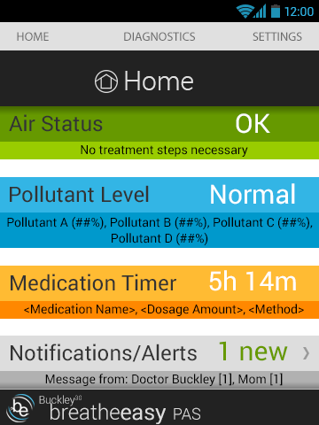

4.2 Diagnostics Screen

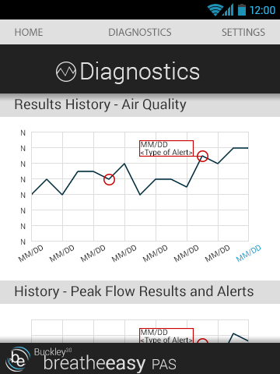

4.3 Settings

a. Security Screen

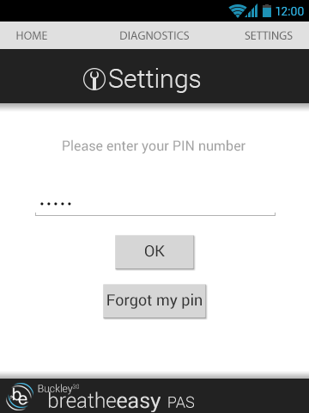

b. Setting Options Screen

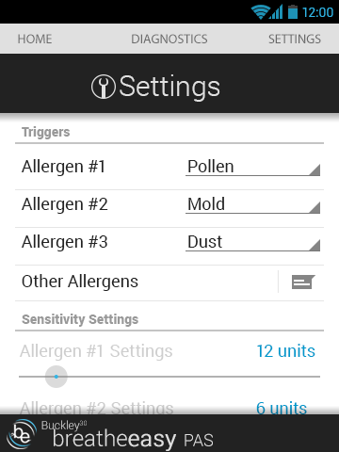

4.4 Status Bar Icons

